Work

7 Cosmos
With another sort. Abracadabra - magic. Cosmos !
This is for factors of seven (7) times some other prime. Sorting first by the *wildcard formula column , and
then by the missing `n' column. All the pieces fall into place. (Note *wildcard formula will become *fam)
Thirty (30) is written all over this table. Remember (1x2x3x5) = 30 ; the first four primes. Things are in the
order of *wildcard formula then missing `n' .
The difference between each non-prime is a constant of two-hundred and ten (210). This is seven (7) times
thirty (30).
The difference between the missing `n' 's is seven (7). Each factor ’s second digit grows by thirty (30). It is the
same for all formulas.

The Tapestry Threads
This is the concept of color threads for factors of seven (7) , they are separated by thirty (30). A color will peak out
through the weave every 30 units , but will be on the seven (7) (*fam07) line. This chart is sorted by the "non-prime" column. Look at 7 x 7 . Then thirty (30) down 7 x 37 . Next , is 7 x 67 . And , "missing n" grows by seven (7) each time. Note that
seven (7) times the first four primes is missing , because they are sorted out already. Note there is a block of eight colors ,
and it repeats in the second factor at 37 , 67 , 97 . . .

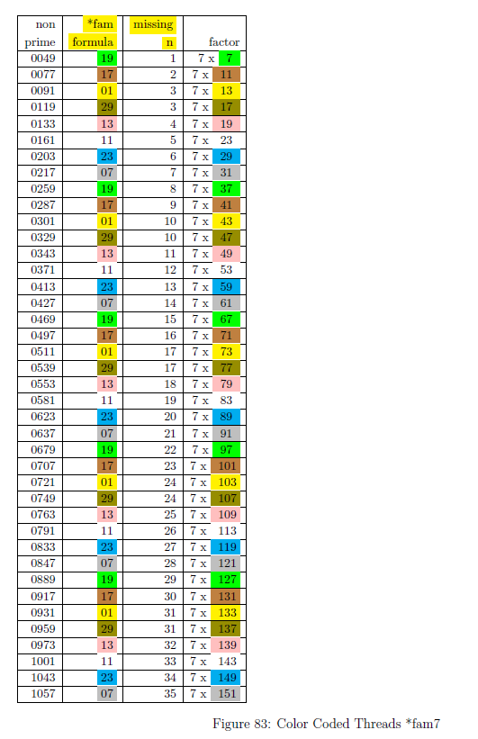

Last Look At 30's
Note: The pdf file “TioCash.pdf” in chapters have additional data and arts and charts.

Since we have eight (8) equations and thirties seem to be the common thread. Let ’s add the two sets of equations
that add up to thirty (30) and chart the data with some sorts.
So , *fam1 and *fam29 are joined and sorted. Then *fam7 and *fam23 , and on and on . . .
Here are the missing n (MN) values for *fam1 and *fam29. First , sort off the blanks in the first two columns
with the heading of MN. Then merge and sort by the "non p" (non-prime) column. The color codes will assist in
tell which *fam the values come from.

Here are all the *fam joined together , look at columns E , K , Q , and W. These are the compliments to make
thirty (30). The color coding helps to distinguish prime and non-prime numbers. Next , look at the red boxes as
an example. It is the sum for its neighbor and the prior value ; some multiple of thirty (30). So , the columns
labeled "sum" are all thirty (30) apart. The column labeled "div 30" yields the set of numbers 1 , 2 , 3 , . . . 1.
The column labeled "n" is the level in the Cash Pile. There are always a pair , and the pairs go up by plus one
(+1). The column labeled "minus" is the difference for its neighbor and the prior value (labeled "p" and "^ p" (prime
and non-prime)) Added together these equal thirty (30). The fun part is only two differences for each *fam pair ,
and the numbers end in set of even digits (2 , 4 , 6 ,8 ).

‘just another thirty’

After separating a PS (Prime Suspect) by its *fam , several additional rules can be applied.

- *fam ( *fam01 , *fam07 , *fam11 , *fam13 , *fam17 , *fam19 , *fam23 , and *fam29 ) will generate all non-prime numbers.
- For each *fam the next PS is plus 30.
 | *fam01 | *fam07 | *fam11 | *fam13 | *fam17 | *fam19 | *fam23 | *fam29
prime | 1 | 7 | 11 | 13 | 17 | 19 | 23 | 29
PS + 30 | 31 | 37 | 41 | 43 | 47 | 49 | 53 | 59
 | 61 | 67 | 71 | 73 | 77 | 79 | 83 | 89
 | 91 | 97 | 101 | 103 | 107 | 109 | 113 | 119
 | 121 | 127 | 131 | 133 | 137 | 139 | 143 | 149
 | 151 | 157 | 161 | 163 | 167 | 169 | 173 | 179

- Take each *fam and subtract from PS.
- Then divide by 30 to get the level (PSL Prime Suspect Level). This is the height of the PS in the Cash Pile.
  - Look at 7: (7-*fam07)/30 = PSL (level) 0
  - Look at 37: (37-*fam07)/30 = PSL (level) 1
  - Look at 67: (67-*fam07)/30 = PSL (level) 2
  - Just another 30 . . .
- Take the PS and find its square.
- Since the values are fixed distance apart (just another 30) , there are now sub-keys for each *fam. The two sub-keys are constant a difference of 30 , and the PSL (level) will grow by the *fam.
- Inside each *fam is a unique set of sub-keys. That cannot be applied to any other *fam.
- These sub-keys will show all non-prime numbers.
- These sub-keys start from the cosmos sorts.

- In the following tables are the sub-keys by *fam. Note that *fam is does not create a non-prime , then PS is prime.

This image is a clear representation of ‘just another 30 away’ .
Only the *fam values are presented. All even , 3 , 5 , and 1/3 's are removed. Each *fam is color coded. And each 'just another 30 away' group is hi-lited. This is the fruit of all the sorts. There is a weave that makes up prime numbers. There are many sub-patterns that need to be investigated.

